From: http://davidstockmanscontracorner.com/why-the-feds-doom-loop-will-take-the-us-economy-down-part-4/

Why The Fed's Doom-Loop Will Take The US Economy Down, Part 4
By David Stockman. Posted On Wednesday, February 27th, 2019

[Stockman is a true Cassandra of our time. He speaks the truth, but nobody is listening!!! -- FNC]
In his Capitol Hill testimony this morning, Jerome "Janet" Powell admitted that the stock market is one of the many factors that the FOMC considers in making policy.
What he didn't say, of course, is that the S&P 500 index is the only consideration that actually matters; and also, the only one it can do much about---albeit even then only in the short-run.
That's because in the short-run the Fed can
- inject cash into the market, thereby elevating securities prices owing to the resulting extra bid for paper; and
- it can also utilize open mouth policy to signal to day traders and algo-machines to "buy", which encourages momo chasers and retail mullets to do the same.
However, when it comes to its purported missions of Economy, the Fed is essentially impotent in the context of an open global economy and domestic sectors already at Peak Debt.
The open economy factor would result in massive demand leakage to foreign suppliers if the FOMC were actually able to stimulate incremental domestic demand (via higher household leverage); and would also generate heavy, oscillating inflows of imported inflation and deflation that would have zero relationship to the Fed's near-term tweaks in the funds rate or the size of its balance sheet.
Likewise, the arrival of Peak Debt means that the Fed cannot stimulate "demand" the old-fashioned way anymore. That is, by adding an incremental layer of spending to household PCE financed by borrowed money on top of that derived from earned wage and salary income.
Needless to say, that old-fashion demand pump was primed in a big way during the run-up to the 2008-2009 financial crisis. As shown below, between the third quarter of 1987 when Greenspan took the helm at the Fed and the pre-crisis peak in the fall of 2007, aggregate wage and salary income (brown line) rose by 179%, but household consumption (blue line) climbed by 215%.
Most of the increment to consumption spending, of course, was funded by the massive rise in household debt during that period. Indexed to Q3 1987 (purple line), it soared by 408%, thereby providing classic monetary oomph to the household spending stream---even if it did freight down balance sheets with a sharply rising leverage ratio as we saw in Part 3.
In fact, during that 20 year period, household debt rose from $2.8 trillion to$14.2 trillion by the eve of the crisis (the dollar level behind the purple line below), amounting to a staggering permanent gain of $11.5 trillion.
So, yes, during this 20-year interval the Fed did "stimulate" household consumption spending to a farethewell. Yet as shown in the next chart---that wasn't real, sustainable prosperity. It was just a pull forward in time of household spending through the medium of balance sheet leverage.
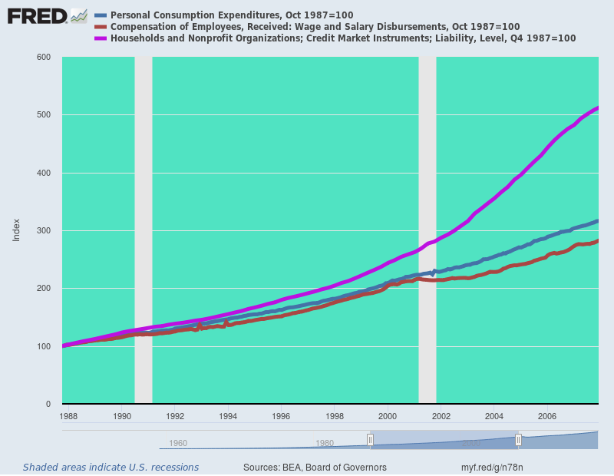
Below is the same chart for the 2007-2018 peak-to-peak period. This time the purple line is on the bottom of the stack, meaning the Fed's easy money had essentially zero effect on household debt accumulation and spending levels; and for the self-evident reason that America's 120 million households in the aggregate had reached a condition of Peak Debt and could no longer boost their spending levels with incremental balance sheet leverage.
In fact, during the last 11 years, household debt grew by only 9% in nominal terms----a tiny fraction of the 408% gain during the 1987-2007 debt and consumption boom; and in inflation-adjusted terms, household debt grew not at all.
By contrast, the 46% gain in PCE (blue line) during this period was almost entirely accounted for by the 37% gain in wage and salary income (brown line), with the balance of the PCE increase largely attributable to rising transfer payments.
Stated differently, whatever the Fed was doing as it goosed its balance sheet from $900 billion to $4.5 trillion during the 2007-2018 period, it wasn't stimulating household demand through the traditional credit channel of monetary transmission.
That was a one-trick pony and at Peak Debt in the household sector, the trick is all used up.
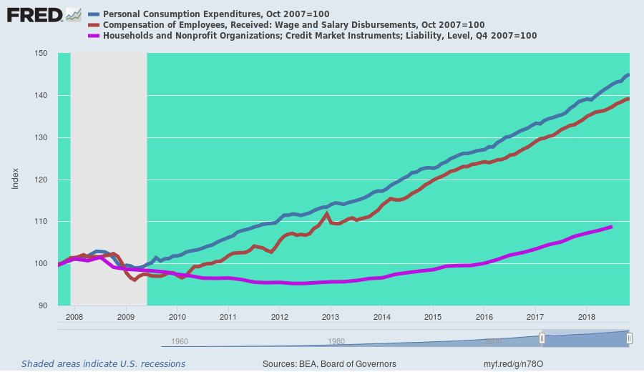
Even if it weren't and the Fed still had efficacious tools to goose real output growth on main street, the 12 Fed heads on the FOMC couldn't actually improve Economy anyway.
That's because they couldn't possibly comprehend what is really happening in the $20 trillion US economy and the $80 trillion global economy of which it is an integral part.
Nor could they accurately measure their putative Humphrey-Hawkins targets such as Full Employment, Moderate interest rates and the endlessly ballyhooed 2.00% Inflation rate; and most certainly their primitive tools, such as pegging the money market rate (Fed funds) or bond-buying at various points on the yield curve, couldn't steer the US economy to these target anyway.
As to the vaunted inflation target, the graph below provides a pretty good demonstration of why Fed's inflation theory is completely and utterly bogus. When you cut through the academic mysticism, what they are really saying is that their real objective is stopping outright deflation, and that the traditional notion of price stability at 0.0% is too close to the purported deflationary danger zone for comfort.
Accordingly, the magic 2.00% annual inflation target is derived from nothing more than a rough and ready margin of safety invented by Bernanke or one of his inflation-targeting co-theorists a few decades back. That is, keep the PCE deflator rising by +2% or better and you won't risk sliding down the dark, slippery slope of negative price level change.
Here's the thing, however. The rate of change in an arbitrary basket of prices designed to approximate the general price level has nothing to do with consumer decision-making and behavior. That's because no one buys the basket---just an endlessly changing and variant mix of consumption goods and services drawn from it.
The graph below was designed for another purpose, of course, which was to show that heavily government regulated, subsidized or otherwise impact goods and services tend to be far more inflationary over time than those supplied more strictly by the free market, where innovation and competitive pressures often result in falling prices over sustained periods of time.
But whatever its original purpose, it cannot be gainsaid that the chart also makes mincemeat out of the Fed's anti-deflation theory. The latter embodies the notion that falling prices will cause consumers to defer purchases, waiting for a better price tomorrow; and that rising price will accelerate purchases today for fear of paying even more tomorrow.
So to goose spending and GDP growth, therefore, you need rising prices and fearful consumers attempting to stay ahead of the inflation curve.
Needless to say, that's Keynesian baloney because over time Say's Law prevails: production and income drive consumption and spending.
Still, the central bankers' anti-deflation proposition should have resulted in soaring hospital usage over the last 20 years, where prices soared by 220%, and a total collapse of TV purchases, where prices plunged by more than 80%.
That's absurd, of course, and embodies what might be termed the inverse fallacy of composition. That is, the proposition that what isn't true for the members of a group nonetheless is true for the group as a whole.
You could call that magic thinking or monetary theology, of course, and be done with it. It bears no relationship to reality or real world behavior of consumers.
Indeed, what the chart really shows is that the aggregate inflation index number is just random math. Actual specific prices for what people buy are all over the lot, and if anything items with falling prices relative to the average encourage more consumption of physical units, not less; and vice versa for items which are rising in relative price.
The irony here, in fact, is that the PCE deflator is a variable rather than fixed weight index, which means that when consumers buy more chicken and less steak due to a rising relative price for the latter, this re-allocation of consumer spending dollars brings down the overall index average relative to a fixed weight deflator.
So you might say, isn't that just ducky. The Fed employs an index based on the very opposite theory of its anti-deflation phobia, and then claims any persistent inflation index shortfall is evidence that its needs a more "accommodative" policy that everywhere and always pleases Wall Street, but is irrelevant to main street Economy.

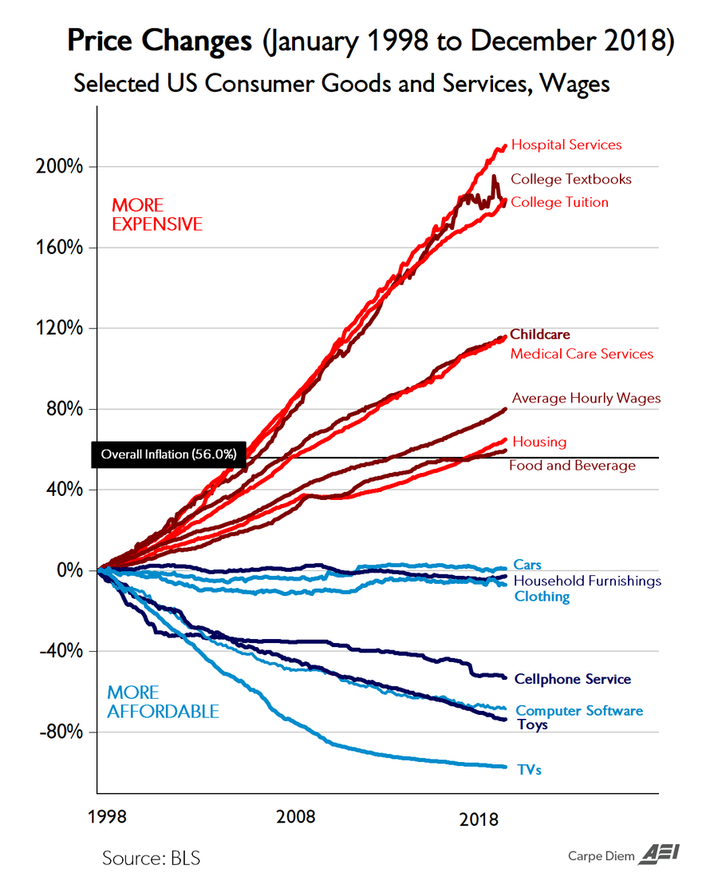
In this instance, in fact, the empirical evidence is dispositive. For the last several decades, the volume of hospital services consumed in the American economy has been falling---notwithstanding the alleged tendency of rapidly rising prices to cause an acceleration of purchases.
At the same time, consumption of cell phones and computer based devices have surged, even as prices have plummeted.
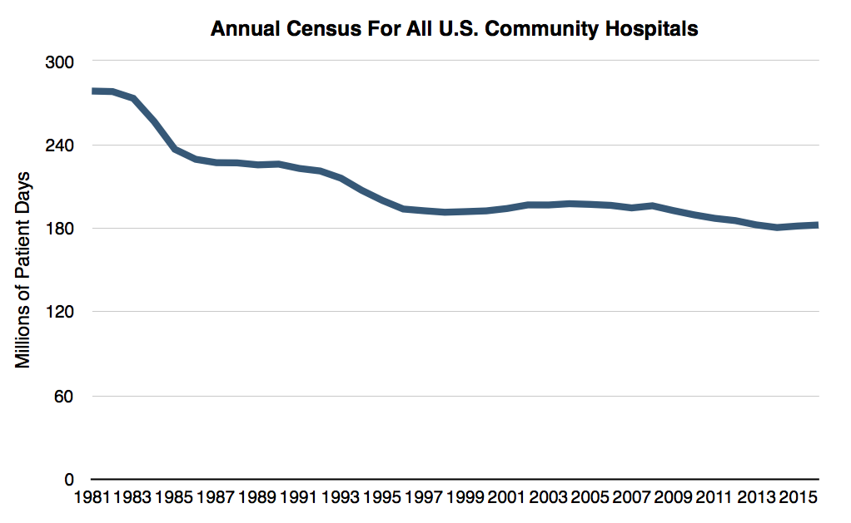
Moreover, as they say on late night TV, there's more. To wit, the price components that go into the PCE deflator basket are not even actual prices paid by consumers at the mall. That's because the government price indices are hedonically adjusted.
For example, the above indices show new car prices virtually flat for the last 20 years because the BLS adjusts transaction prices on the dealer lots for improved features such as air bags or computer controlled engine and transmission features whether they actually provide consumers with increased utility or not.
In fact, new car prices are up about 30% during the same 20 year period, yet annual new car purchases averaged over the cycle and relative to driving age population changed hardly at all.
In other words, the Fed's anti-deflation theory is complete malarkey. But as we will demonstrate in Part 5, it is the fig leaf by which the Fed pretends to be pursuing Economy--- even as it functions as the abject handmaid of Wall Street speculators.

